Stock 1: Discover Financial:

Stock 2: Genaral Mills:

Stock 3: Gilead Science:

**Prospectus WOL Sustainable Equity Fund**

Word count starts here (max 2500 words)

**Part 1: Risk and Return Analysis**

Table1 gives results of the stock volatility, correlation, average return and Sharpe ratio of (DFS, GIS, GILD) and the S&P 500 (^GSPC). Although DFS demonstrated the highest average annual return of all the stocks (16.32%), this was also coupled with the highest volatility (standard deviation of 37.24%) hence resulting in a negative Sharpe Ratio (-3.0952). This suggests DFS might be a riskier investment despite the higher returns. General Mills (GIS) and Gilead Sciences (GILD) revealed lower returns (8.26% and 7.26% respectively) against the S&P 500 (11.17%) but with a smaller volatility. Both GIS and GILD shows negative Sharpe ratio (-5.9745 and -4.6721, respectively). Among all four indices, S&P 500 performed the best by having a lower volatility and a small Sharpe ratio indicating that it could have been a more stable investment compared to others. Surprisingly, the positive correlation between S&P 500 and GIS indicates that the performance of that stock might not be much better than the one of the S&P 500 so investing in both might not give you such a significant diversification benefit.  
The line plot in figure 2 shows the investment return on the three stocks and the s&p500. The graph is able to show how closely GIS is related to the s&p500. The heat map in figure 1 equally shows the correlation among the three stocks and s&p500.

**Part 2: ESG analysis**

Table 2 provides a comprehensive overview of the ESG risks associated with three companies: According to Discover Financial's ESG Score of 0.4829, the score is below the industry average with an overall score of 0.5566. Such an observation indicates that the company trails behind its peers in general in the field of ESG and potentially has some gaps in its approach to these factors. The company’s ESGC Controversies Score is 0.5671 , and it means that the business has had controversies which may affect significantly its ESG performance. Its CCexposure including the overall climate change exposure is 0.0004, which classifies it as low climate change exposure.

General Mills, had a ESG Combined Score of 0.5385, which is well under the industry average of 0.6455. This implies possible ESG progress areas which the company needs to address. The firm holds a ESGC Controversies Score of 0.2876 evidently less than that of DFS. The general climate change exposure of this firm compared to Discover Financial is nearly the same and this is estimated as 0.0003.

In terms of the current ESG combined score for Gilead Sciences, Inc. which is 0.5385 is below average industry score of 0.6931. This therefore implies the company may also have areas where ESG performance does not measure up to those of its peer competitors in the industry. The company’s ESGC Controversies Score is assessed at about 0.3493 based on controversies level. Hence, there is some level of controversy. Holding things all together, its climate change vulnerability score becomes the lowest among the three companies at 0.0001.

1. Discover Financial (DFS):

Based on their 2022 report (https://investorrelations.discover.com/investor-relations/overview/default.aspx), we can glean some insights into their ESG strategy:

Focus on Diversity, Equity, and Inclusion (DE&I): Discover established a DE&I Council and set specific goals for workforce representation (https://investorrelations.discover.com/investor-relations/overview/default.aspx, p. 44). They also launched unconscious bias training and implemented supplier diversity programs (p. 44).

Environmental Initiatives: The report mentions Discover's commitment to responsible paper sourcing and reducing their environmental footprint (p. 45). However, specific details on mitigating climate change risks are limited.

Recommendation:

To better understand Discover's current ESG risk mitigation plans, it's crucial to wait for their 2023 Annual Report. This report will likely detail their progress on DE&I goals and any updates on environmental initiatives.

2. General Mills (GIS):

General Mills' 2023 Sustainability Report (https://globalresponsibility.generalmills.com/) outlines a comprehensive approach to mitigating ESG risks:

Sustainable Sourcing: General Mills prioritizes responsible sourcing of agricultural ingredients, aiming to reduce their environmental impact (p. 12). They also focus on ethical labor practices within their supply chain (p. 13).

Climate Change: The company has set ambitious goals for reducing greenhouse gas emissions (p. 17) and is investing in renewable energy sources (p. 18).

Packaging Sustainability: General Mills aims to make 100% of their packaging recyclable or compostable by 2030 (p. 21).

Recommendation:

General Mills provides a transparent and detailed approach to ESG risk mitigation. Investors can monitor their progress through their annual sustainability reports.

3. Gilead Sciences (GILD):

Gilead Sciences' 2023 Environmental, Social, and Governance (ESG) Report (https://www.gilead.com/purpose/esg) details their ESG efforts:

Access to Medicines: Gilead focuses on improving access to their medications in developing countries through various programs (p. 12).

Environmental Sustainability: They have set goals for reducing waste, water usage, and greenhouse gas emissions (p. 18).

Recommendation:

Gilead's ESG report provides a good overview of their risk mitigation strategies. Investors can track their progress through future ESG reports.

**Part 3: Portfolio allocation**

The table of variance-covariance matrix provides the investors with the opportunity to observe return relations across various assets that are included in their portfolio. Every matrix element gives us very precious information about the covariance between the returns of two particular assets and each asset's volatility itself. For instance, positive covariance of assets can be described, as two companies such as Discover Financial (DFS) and General Mills (GIS) whose returns show similar trends over time. By contrast, negative covariance show the opposite pattern in returns.  In this specific example, DFS has the highest variance, which is 0.1387, hence DFS has the most variation among the three stocks. In the case of GIS and GILD, variability is lower (0.0426 and 0.0710 respectively) indicating a lower volatility. The DFS and GILD pair has the highest correlation at 0.0238.

Table 4 illustrates minimum-riskportfolio and also Tangency portfolio. The portfolios with the minimal variance are concentration on the risks minimizing. The alorithim assigned the lowest weight i.e. 13% to Discover Financial (DFS) and assigned the highest weight of 60% to General Mills (GIS).It is likely that DFS has the highest individual risk, and GIS probably has the lowest risk. This portfolio has a smaller standard deviation (0.175) than that of the tangency portfolio (0.192). On the other hand, the negative return is about 0.0905, making the expected return drop  
 The tangency portfolio strikes a balance between risk and return. The portfolio allocated a higher weight (34%) to DFS, which offers the potential for higher returns, and a lower weight (54%) to GIS compared to the minimum-variance portfolio. This results in a slightly higher standard deviation but a significantly better expected return (0.0186).  
  
 The minimum-variance portfolio has a lower Sharpe Ratio (0.5162), indicating that the return isn't as high relative to the risk taken. The Sharpe Ratio of the tangency portfolio (0.5653) is a higher, which means that the risk's distribution is more balanced with the risk reward ratio.  
  
The correlation between the two portfolios is also positive (0.0307). This implies that usually portfolios tend to move in the same direction although with different magnitude. This suggests some overlap in the types of assets held in both portfolios.

Table 5 shows the Portfolio Frontier, which is comprised from different weights combination of the minimal-variance portfolio and is a representation of the trade-off between risk (expressed by standard deviation) and the return. When the minimum-variance portfolio has a weighting from 0 to 1, both the standard deviation and the expected return begin from high levels and then decrease, this translates to a positive relationship between risk and return. Surprisingly, the range of the Sharpe ratio which is a risk-adjusted return measure first goes up and then down when included at the weight of 0.5 where its highest point is achieved. In the scenario where the weighting of the minimum-variance portfolio were 0.5, it offers the most risk-adjusted return. As the minimum-variance portfolio weight grows, the ESG score gradually, which reflects the environmental, social and governance exposure of the portfolio, increases.

The fund has a score of 0.75 for its ESG shows a good level of performance in the environmental, social and governance criteria. The equity weights assigned to stocks in the fund consist of 20% Discover Financial, 40% General Mills, and 40% Gilead Science. The fund's portfolio return has 0.095, and its risk standard deviation is 0.15. The fund exhibits a Sharpe ratio of 0.63 that adjusts for risk.  
  
 However, the Tangency portfolio, corresponding with your previous cases, possesses 0.63 rating in terms of ESG and the weightage assigned are 0.34 for Discover Financial, 0.54 for General Mills and 0.13 for Gilead Science. The portfolio return is 0.0186, the standard deviation is 0.192, and he Sharpe ratio is 0.5653.  
  
 Comparing QMUL Sustainable Equity Fund with Invesco Sustainable Global Equity Fund we can see that the fund has higher ESG score and lower Sharpe ratio, which means that the fund performs better in terms of environmental, social, and governance factors and risk-adjusted return, while the other fund has the opposite results. Its portfolio return is higher and its risk is lower compared to Tangency portfolio. This shows that QMUL Sustainable Equity Fund, as an ESG-oriented and risk-adjusted return-oriented investment vehicle, could be more appealing to the investors seeking their portfolios a higher exposure to ESG factors.Tangency portfolios could be attractive to those who are able and willing to take higher risks in search of the steeper return curve.

**Part 4: Active ownership**

For Discover Financial (DFS), the QMUL Sustainable Future Equity Fund the shareholders' proposal focuses on the environmental pillar score, which GES score is at a significantly lower level compared to the industry average GES score. The program will be centered on the proposal of making Discover Financial pursue the improvement of its environmental sustainability function, the reduction of carbon emissions, augmentation of energy efficiency and the adoption of environmentally friendly practices across every business operation. Through the supremacy of the Environment stewardship, the case intends to synchronize Discover Financial and global sustainability purposes that finally will help in limiting environmental risks and increasing value for the Shareholders. It also matters that the fund tries, in cooperation with the Discover Financial management, to inform on, and improve the environmental position of the company by engaging in transparency, accountability and taking proactive attitude towards sustainability.

For GIS the disputed matter will concern the controversies mark in the ESG categories. General mills scored well on overall ESG score. The only drawback in its performance is shown in the controversies score. The proposal shall therefore, be pushing for openness on these issues as well as accountability of the decisions and strategies followed to handle ethical questions surrounding the business practices of General Mills. For example, it could mean steps such as enhancing supply transparency, labor practices or structures of corporate governance. The proposal aims at instructing General Mills to address controversies cautiously in a way which not only enhances the company's stakeholder trust, but also safeguards the company's reputation and ethical standards. In the end, this initiative takes an effort to be responsible in business conduct and as a result General Mills can be part of a sustainability and shareholder value success.

For Gilead Sciences (GILD) te propasal should address governance pillar score that is lower compared to the other ESG indicators. The proposal will advocate to improve board oversight, grow transparency and match executive payment with solid and multilateral success. This could include actions such as the inclusion of independent directors on boards, applying best corporate governance practices, and the disclosure of corporate executive pay structures. The proposal targets to alleviate the risk of poor governance by strengthening the practices and process as a means of improving decision making and therefore gaining the confidence of investors in the Gilead Sciences Company. Primarily, the proposed system of excellence in governance will serve to help Gilead Sciences to be more durable and create more value in the future for the shareholders.

**Part 5: Performance or Sustainability**

A piece of research that is of great significance in this field is the meta-analysis done by Gunnar Friede, Timo Busch, and Alexander Bassen in 2015 (Friede, Busch, & Bassen, 2015). Their study, titled “ESG and Financial Performance: Aggregated Evidence from More than 2000 Literature,” reviewed the results of over 2000 empirical studies focusing on interlinks between ESG and financial results. The meta-analysis confirmed that among the studies reviewed, the most were finding out that there is a positive link between high ESG scores and corporate finance performance. This implies that we can also achieve super normal long term returns if we use ESG criteria in our investment decision making.

Nevertheless, the sustainability benefits considerations is growing, but fund managers face challenges in executing their ESG strategies. One of the principal issues in this matter includes the belief that applying sustainable methods has to be traded for short-term financial effectiveness. This concern is echoed in a study by Mozaffar Khan, George Serafeim, and Aaron Yoon in 2016 (Khan, Serafeim, & Yoon, 2016), titled "Corporate Sustainability: The journal based the content on “First Evidence on Materiality.” The study suggested that investors may treat various sustainability efforts as destructive tools, which result in transferring of limited resources from attempts of maximizing shareholder wealth to the benefit of the environment in the short term.

On the other hand, fund managers could also face the challenge of finding the right ways to measure and translate into quantifiable metrics the financial impact of ESG factors on performance. This challenge is highlighted in a study by Tessa Hebb and Elroy Dimson in 2016 (Hebb & Dimson, 2016), titled “The Dark Side of Portfolio Allocation: “A Glimpse of Accumulating Evidence of Active Shareholder Engagement”. Even though the traditional financial metrics are no longer able to completely present the full spectrum the risks and opportunities associated with the ESG factors that hinder fund managers to fully incorporate these considerations into the investment decisions

**Reference list:**

Friede, G., Busch, T., & Bassen, A. (2015). ESG and Financial Performance: Aggregated Evidence from More than 2000 Literature.

Khan, M., Serafeim, G., & Yoon, A. (2016). Corporate Sustainability: First Evidence on Materiality.

Hebb, T., & Dimson, E. (2016). The Dark Side of Portfolio Allocation: A Glimpse of Accumulating Evidence of Active Shareholder Engagement.

**Appendix:**

**Include in your appendix all your calculations, tables, and figures. Please do not include Python codes.**

**Appendix Part 1:**

**Table 1: Risk and Return Analysis**

|  |  |  |  |  |
| --- | --- | --- | --- | --- |
|  | **Discover Financial:**  **DFS** | **Genaral Mills:**  **GIS** | **Gilead Science:**  **GILD** | **S&P500**  **^GSPC** |
| **Average annual returns** | **0.16321** | **0.0826** | **0.0726** | **0.1117** |
| **Annual standard deviation** | **0.3724** | **0.2064** | **0.2661** | **0.1774** |
| **Sharpe ratio** | **-3.0952** | **-5.9745** | **-4.6721** | **-6.78824** |
| **Correlation coefficients** |  |  |  |  |
| **Genaral Mills: GIS** | **0.1316** |  |  |  |
| **Gilead Science: GILD** | **0.2404** | **0.2617** |  |  |
| **S&P500: ^GSPC** | **0.6927** | **0.3476** | **0.4440** |  |

**Figure 1:**

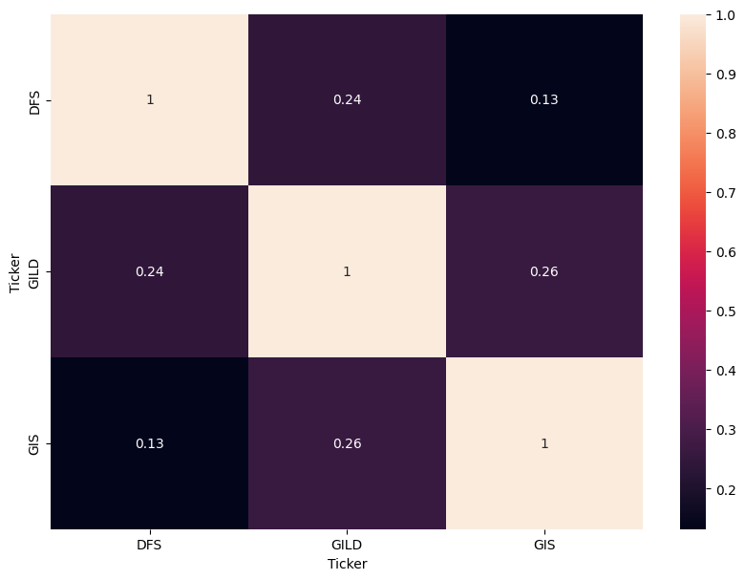

**Figure 2:**

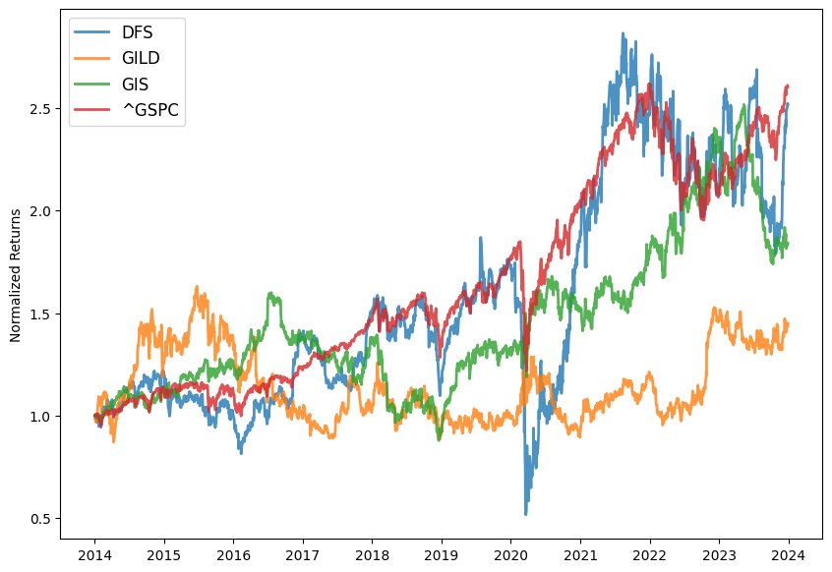

**Appendix Part 2:**

**Table 2: ESG Risks**

|  |  |  |  |
| --- | --- | --- | --- |
|  | **Discover Financial:**  **DFS** | **Genaral Mills:**  **GIS** | **Gilead Science:**  **GILD** |
| **ESG Combined Score** | **0.4829** | **0.5385** | **0.5385** |
| **ESGC Controversies Score** | **0.5671** | **0.2876** | **0.3493** |
| **ESG Score** | **0.599** | **0.7892** | **0.8199** |
| **Environment Pillar Score** | **0.3511** | **0.8811** | **0.7093** |
| **Governance Pillar Score** | **0.7159** | **0.4496** | **0.8845** |
| **Social Pillar Score** | **0.623** | **0.9274** | **0.8710** |
|  |  |  |  |
| **Industry average ESG score** | **0.5566** | **0.6455** | **0.6931** |
|  |  |  |  |
| **CCexposure** | **0.0004** | **0.0003** | **0.0001** |
| **CCexposure Opportunity** | **0.00008** | **0.0000** | **0.0000** |
| **CCexposure Regulatory** | **0.0002** | **0.0002** | **0.0000** |
| **CCexposure Phyisical** | **0.0000** | **0.0000** | **0.0000** |

**Appendix Part 3:**

**Table 3: Variance-Covariance-Matrix**

|  |  |  |  |
| --- | --- | --- | --- |
|  | **Discover Financial:**  **DFS** | **Genaral Mills:**  **GIS** | **Gilead Science:**  **GILD** |
| **Discover Financial: DFS** | **0.1387** | **0.0101** | **0.0238** |
| **Gilead Science: GILD** | **0.0238** | **0.0143** | **0.0710** |
| **Genaral Mills: GIS** | **0.0101** | **0.0426** | **0.0144** |

**Table 4: Minimum-variance and tangency portfolio weights**

|  |  |  |  |  |  |  |
| --- | --- | --- | --- | --- | --- | --- |
|  | **Weight**  **Discover Financial:** | **Weight**  **Genaral Mills:** | **Weight**  **Gilead Science:** | **Portfolio**  **Return** | **Portfolio Standard Deviation** | **Portfolio Sharpe Ratio** |
| **Minimum-variance** | **0.13** | **0.6** | **0.27** | **0.0905** | **0.175** | **0.5162** |
| **Tangency portfolio** | **0.34** | **0.54** | **0.13** | **0.0186** | **0.192** | **0.5653** |

**Covariance (Minimum-variance, Tangency portfolio) = 0.0307**

**Add here the calculation for Table 4**

**covariance_min_var_efficient=wminT​×covar×wsharpe​**

**Where:**

* **wmin​ is the weight vector for the minimum-variance portfolio.**
* **covar is the covariance matrix.**
* **wsharpe​ is the weight vector for the tangency portfolio**

**Table 5: Portfolio Frontier**

|  |  |  |  |  |  |
| --- | --- | --- | --- | --- | --- |
|  |  | **Portfolio standard deviation** | **Portfolio expected return** | **Sharpe ratio** | **Portfolio ESG score** |
| **w1=** | **0** | **0.1921** | **0.1085** | **0.5653** | **0.6214** |
|  | **0.1** | **0.1737** | **0.1068** | **0.6148** | **0.6239** |
|  | **0.2** | **0.1576** | **0.1050** | **0.6661** | **0.6264** |
|  | **0.3** | **0.1444** | **0.1032** | **0.7146** | **0.6290** |
|  | **0.4** | **0.1349** | **0.1014** | **0.7513** | **0.6315** |
|  | **0.5** | **0.1300** | **0.0996** | **0.7656** | **0.6340** |
|  | **0.6** | **0.1303** | **0.0977** | **0.7503** | **0.6365** |
|  | **0.7** | **0.1356** | **0.0959** | **0.7075** | **0.6390** |
|  | **0.8** | **0.1454** | **0.0941** | **0.6472** | **0.6416** |
|  | **0.9** | **0.1590** | **0.0923** | **0.5807** | **0.6441** |
|  | **1** | **0.1754** | **0.0905** | **0.5162** | **0.6466** |

**Figure 3:**

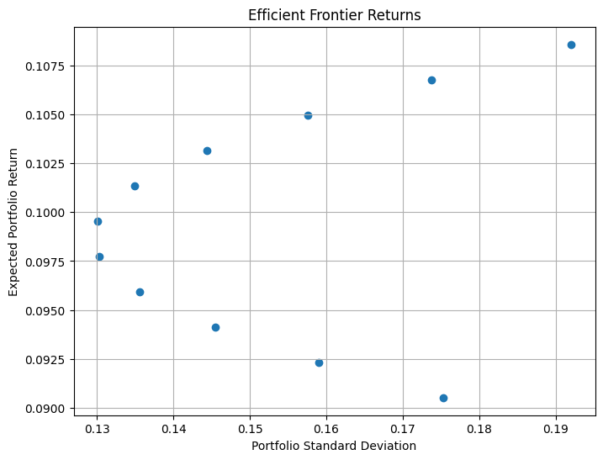

**Figure 4:**

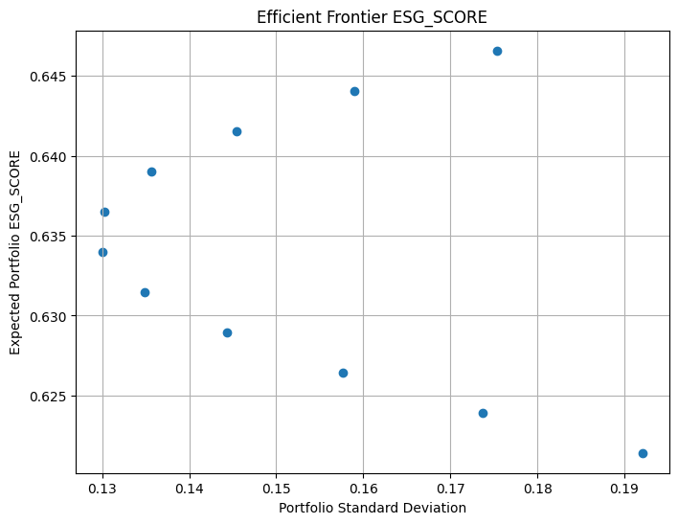

**Appendix Part 4:**

Table 5: Shareholder proposals

|  |  |
| --- | --- |
|  | Shareholder Proposal |
| Discover Financial:  DFS | Improve the Environmental Pillar Score. |
| Genaral Mills:  GIS | Improve governance pillar score |
| Gilead Science:  GILD | Improve the controversies Esg Score |